Last Spotted Location of the User | DATEPART | RANK

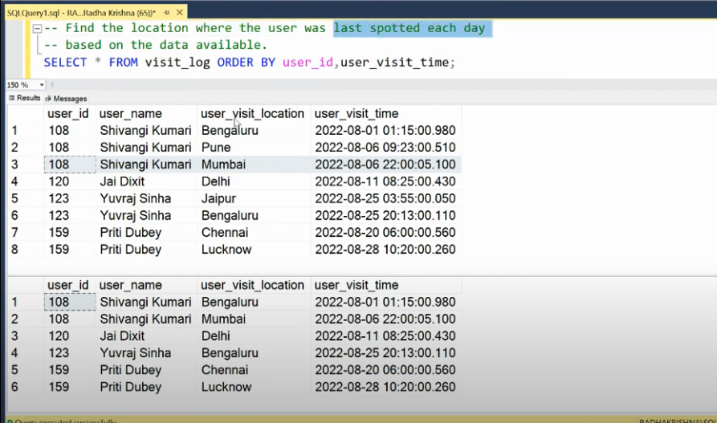

with cte1 as (

select * , DATEPART(day,user_visit_time) as day_num from visit_log ), cte2 as (

select * , row_number() over(partition by user_id,day_num order by user_visit_time desc) as rn from cte1)

select * from cte2

where rn=1

Finding Total Duration Device is "ON" | CASE | GROUP BY

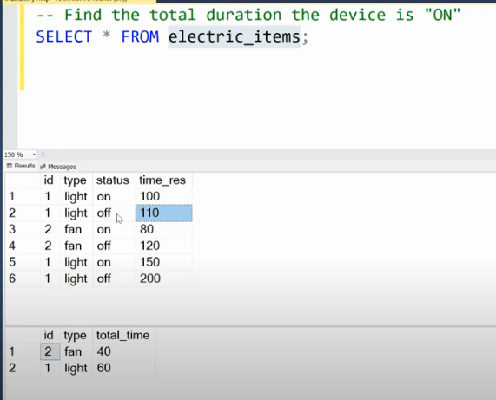

with on_time as (

select id,type,sum(time_res) as total_on_Time

from electric_items

where status = 'on'

group by id,type),off_time as (

select id,type,sum(time_res) as total_off_Time

from electric_items

where status = 'off'

group by id,type)

select a.id,a.type,(b.total_off_Time-a.total_on_Time) as total_time from on_time as a

join off_time as b

on a.id=b.id

OR

with cte1 as (

select id,type,

sum(case when status ='on' then time_res end)as on_time,

sum(case when status ='off' then time_res end)as off_time

from electric_items

group by id,type)

select id,type,(off_time-on_time) from cte1

-- SQL Loop | Generate numbers from 1 to 5000 | Recursive CTE

-- recursive cte

with num_cte as

(

select 1 num

union all

select num+1 as num from num_cte

where num<5000

)

select * from num_cte

option(MAXRECURSION 6000);

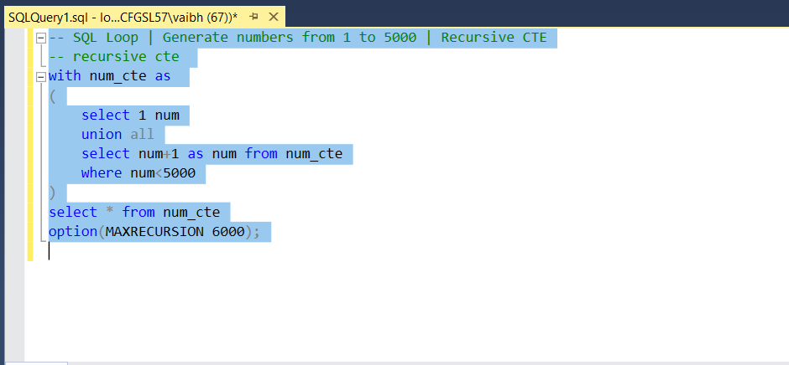

Finding Topper of the class | DENSE RANK | CASE

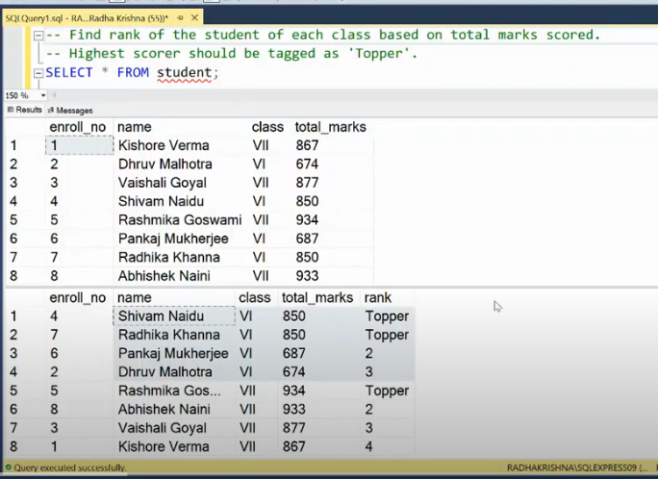

WITH cte1 AS (

SELECT *,

DENSE_RANK() OVER (PARTITION BY class ORDER BY total_marks DESC) AS stu_rank

FROM student

)

SELECT enroll_no, name, class, total_marks,

CASE WHEN stu_rank = 1 THEN 'Topper' ELSE CAST(stu_rank AS VARCHAR(10)) END AS rank_cleaned

FROM cte1;

Find Grandparent column

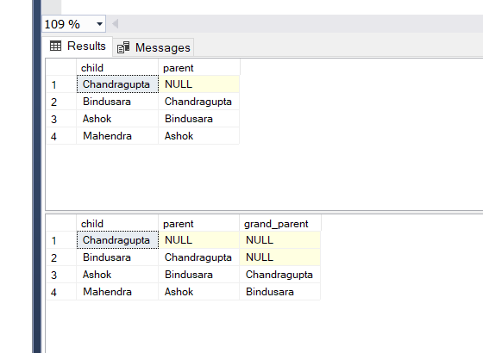

select a.*,b.parent as grand_parent from family as a

left join family as b

on a.parent=b.child;

Finding Interview Eligible Candidates

--In this SQL problem solving session, we will be solving problem of finding the candidates that are eligible for further interviews based on 2 criteria -

--(1) Candidate should not have appeared for 2 or more interviews.

--(2) Candidate should not have appeared for interviews within 180 days (6 months).

select * from candidate;

with cte_1 as (

select id,name,max(interview_date) as last_interview_date,count(1) as interviews_count,

DATEDIFF(day,interview_date,'2023-08-16') as day_diff

from candidate

group by id,name)

select *,

case when interviews_count >= 2 or day_diff <= 180 then 'no'

else 'yes' end as eligible_status

from cte_1

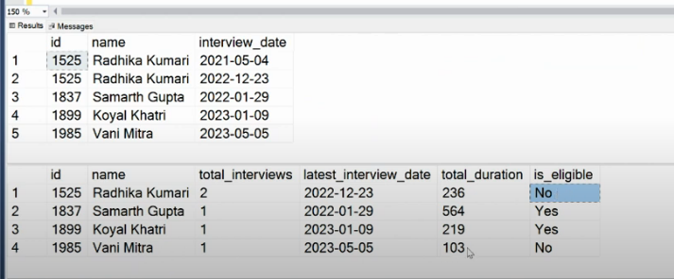

**Replacing NULLs with previous values**

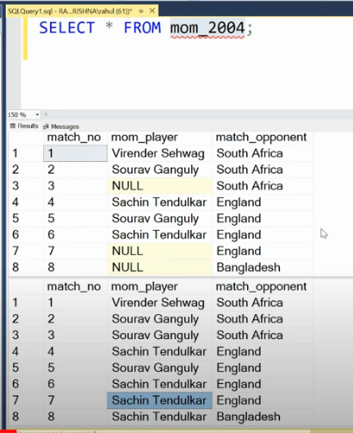

with cte as (

select *,count(mom_player) over(order by match_no) as grp from mom_2004)

select match_no,FIRST_VALUE(mom_player) over(partition by grp order by match_no) as mom_player,match_opponent from cte

Finding maximum items customers can purchase within allocated budget |

STRING_AGG

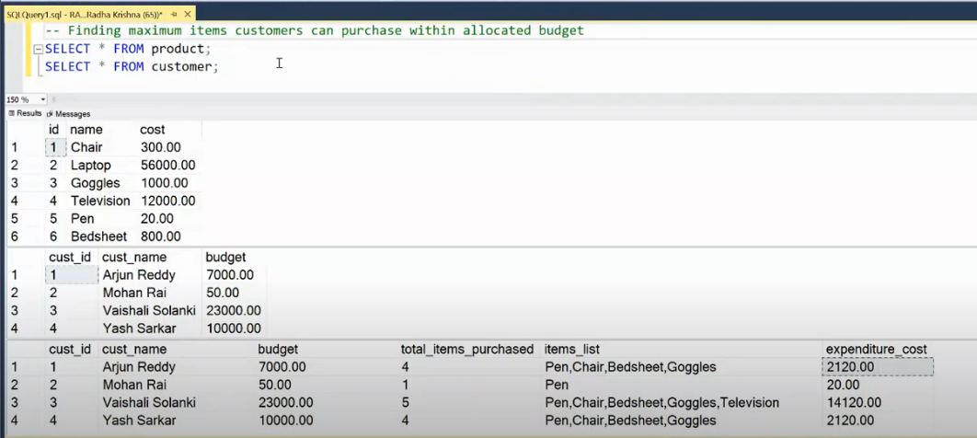

with cte1 as (

select a.* , b.name ,count(b.name) over(partition by a.cust_id) as product_count,b.cost from customer as a

join product as b

on b.cost <= a.budget)

select distinct cust_id,cust_name,budget,product_count ,STRING_AGG(name,',') as items_list,sum(cost) as expenditure_cost

from cte1

group by cust_id,cust_name,budget,product_count;

Getting Gym attend date ranges

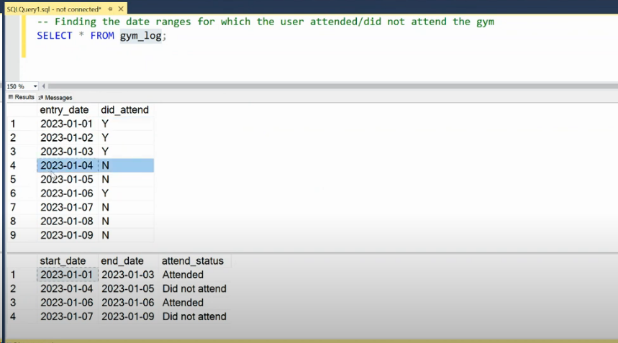

with cte1 as (

select * , row_number() over(partition by did_attend order by entry_date asc) as rnk ,

DATEADD(day,-row_number() over(partition by did_attend order by entry_date asc),entry_date) as group_date

from gym_log)

select min(entry_date) as start_date,max(entry_date) as end_date ,

case when did_attend='y' then 'Attended' else 'not attended' end as status

from cte1

group by did_attend,group_date

order by start_date asc

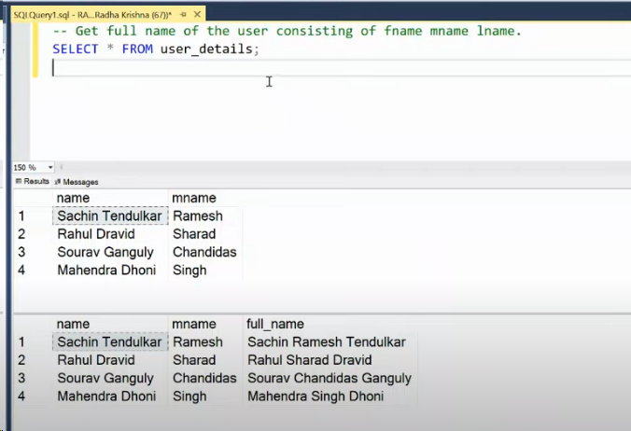

select * , CONCAT_WS(' ',SUBSTRING(name,1,charindex(' ',name)),mname,SUBSTRING(name,CHARINDEX(' ',name),len(name))) as full_name

from user_details;

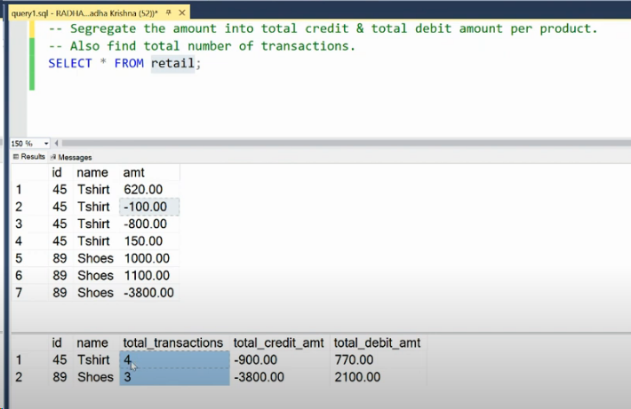

select

id,[name],count(*) as total_transactions,

sum(case when amt < 0 then amt end) as debit_amount,

sum(case when amt > 0 then amt end) as credit_amount

from retail

group by id,[name]

order by id;

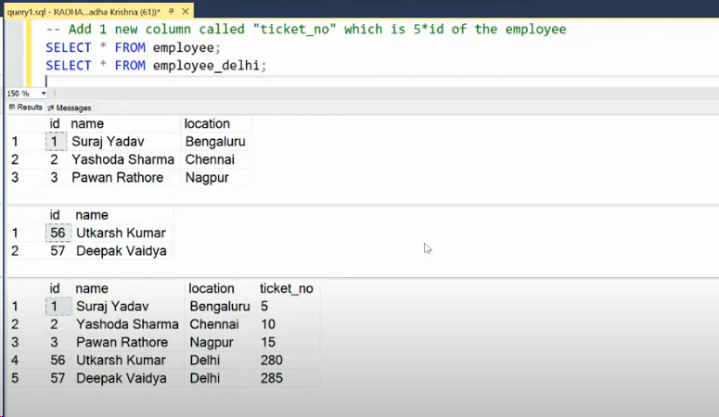

select id,[name],[location],id*5 as ticket_no from employee

union all

select id,[name],'Delhi' as [location],id*5 as ticket_no from employee_delhi

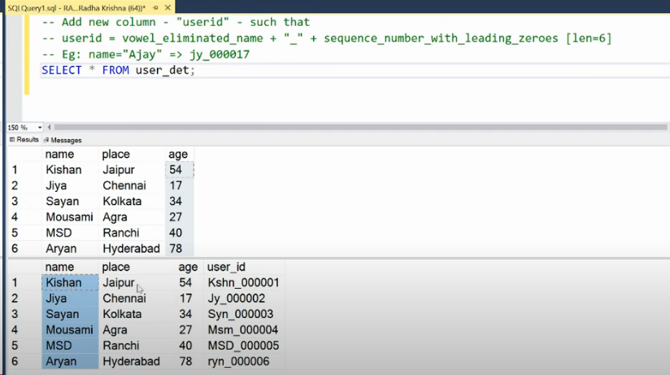

with cte as (

select *,REPLACE(REPLACE(REPLACE(REPLACE(REPLACE(name, 'a', ''), 'e', ''), 'i', ''), 'o', ''), 'u', '') AS removed_vowels,

REPLICATE(0,6-len(ROW_NUMBER() over(order by (select null)))) as replicated_num,

ROW_NUMBER() over(order by (select null)) as row_id

from user_det)

select [name],place,age,CONCAT(removed_vowels,'_',replicated_num,row_id) from cte

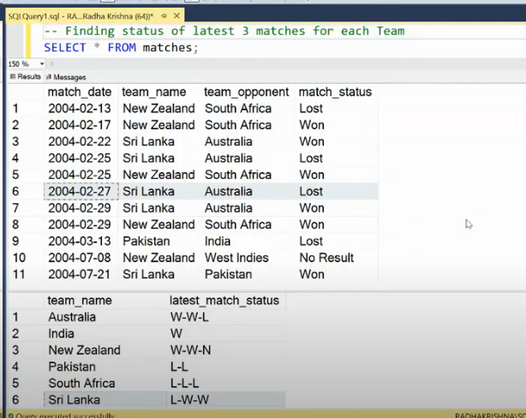

with cte1 as (

select team_name as player , match_date,

case when match_status = 'Won' then 'W'

when match_status ='Lost' then 'L'

else 'N' end as match_status_DC

from matches

union all

select team_opponent as player , match_date,

case when match_status = 'Won' then 'L'

when match_status ='Lost' then 'W'

else 'N' end as match_status_DC

from matches),cte2 as (

select player as player_team , match_status_DC , ROW_NUMBER() over(partition by player order by match_date desc) as rn

from cte1)

select player_team,STRING_AGG(match_status_DC, '-') from cte2

where rn <=3

group by player_team

order by player_team

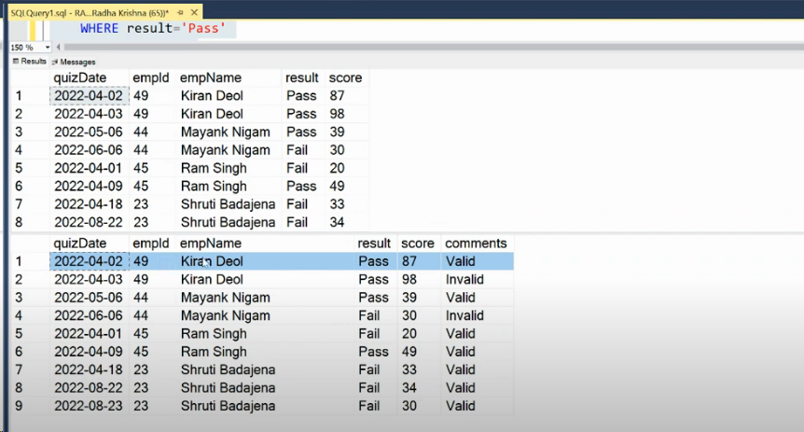

Marking records invalid after first "Pass" status

with cte1 as (

select empid,min(quizdate) as first_quizdate from quiz

where result = 'pass'

group by empid)

select a.*

,case when

b.first_quizdate is null or quizDate <= b.first_quizdate then 'valid'

else 'invalid' end as comments

from quiz as a

left join cte1 as b

on a.empid =b.empid

order by empid desc,quizDate;

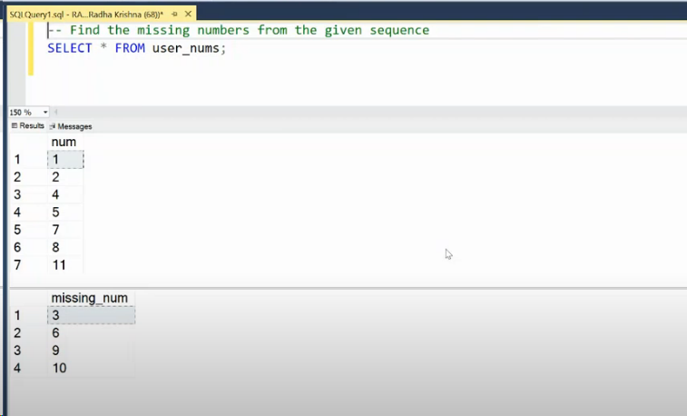

Finding the missing numbers from given sequence

with cte as (

select 1 as num

union all

select num+1 from cte

where num <11

)

select * from cte

except

select * from user_nums

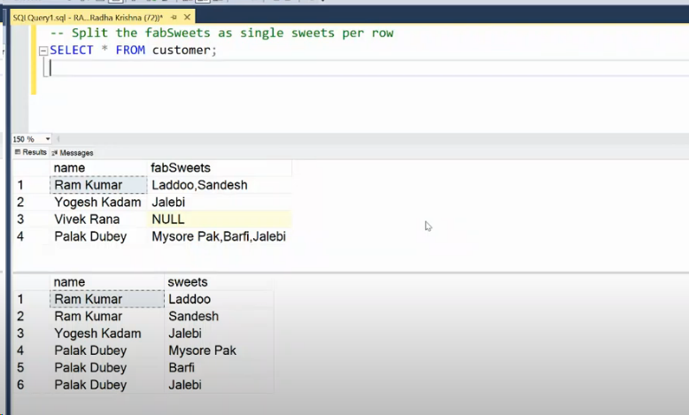

Split list of sweets into multiple records

select [name],value as sweets

from customer_sweets

cross apply string_split(fabSweets,',') as cn_list

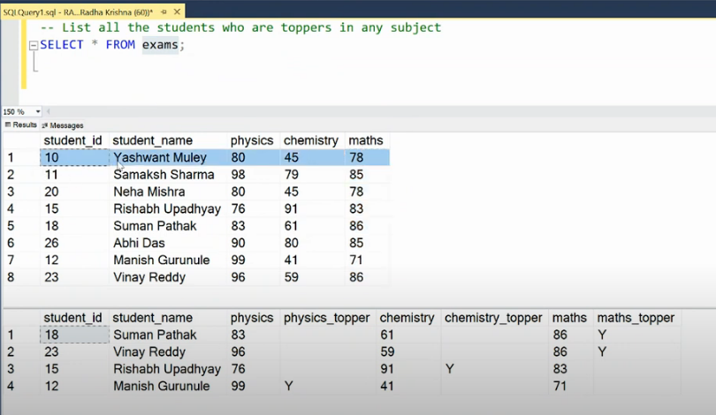

Listing students who are topper in any subject

with cte1 as (

select student_id,student_name ,physics , DENSE_RANK() over(order by physics desc) as prnk

from exams),

cte2 as (

select student_id,student_name ,chemistry , DENSE_RANK() over(order by chemistry desc) as crnk

from exams) ,

cte3 as (

select student_id,student_name ,maths , DENSE_RANK() over(order by maths desc) as mrnk

from exams)

select a.student_id,a.student_name ,physics,

case when prnk = 1 then 'y' else '' end as physics_topper,chemistry,

case when crnk = 1 then 'y' else '' end as chemistry_topper,maths,

case when mrnk = 1 then 'y' else '' end as maths_topper

from cte1 as a

join cte2 as b on a.student_id = b.student_id

join cte3 as c on a.student_id = c.student_id

where prnk=1 or crnk = 1 or mrnk = 1

order by a.student_id;

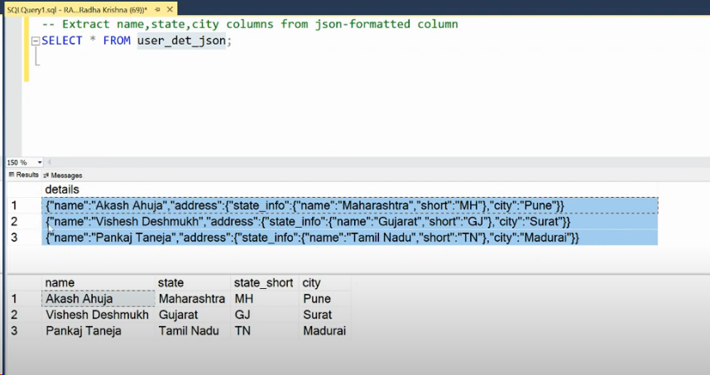

SQL JSON Input | Extracting columns from JSON formatted data

SELECT

JSON_VALUE(details, '$.name') AS PersonName,

JSON_VALUE(details, '$.address.state_info.name') AS StateName,

JSON_VALUE(details, '$.address.state_info.short') AS StateShort,

JSON_VALUE(details, '$.address.city') AS City

from user_det_json;

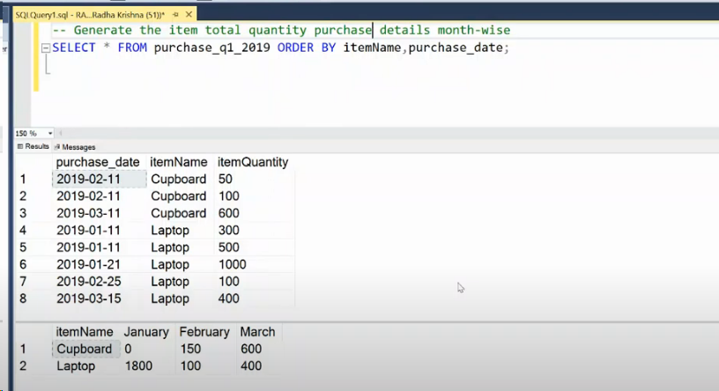

SQL Pivot | Generating item total details month-wise

select itemName,

sum((case when month(Purchase_date)= 1 then itemQuantity end)) as january,

sum(case when month(Purchase_date)= 2 then itemQuantity end) as Feb,

sum(case when month(Purchase_date)= 3 then itemQuantity end) as March

from purchase_q1_2019

group by itemName

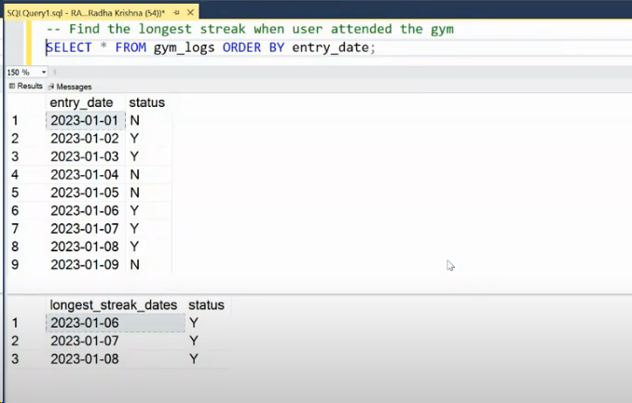

Finding longest streak when user attended gym

with cte1 as (

select entry_date,[status],row_number() over(order by entry_date) - row_number() over(partition by [status] order by entry_date) as grp

from gym_logs)

select entry_date,[status] from cte1

where [status]='Y' and grp = (select max(grp) from cte1 where [status]='Y');

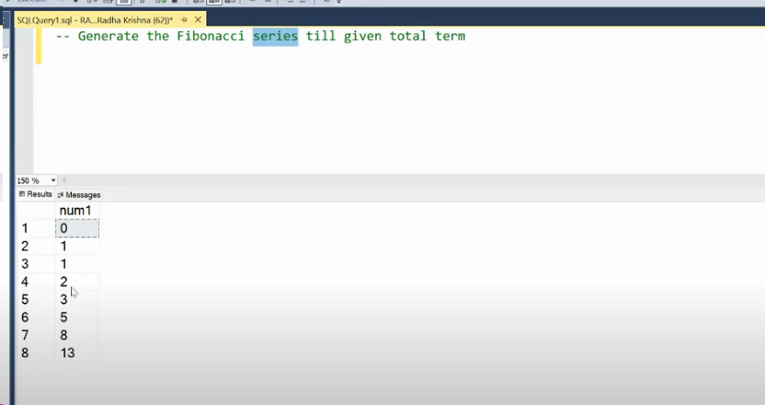

Generate the Fibonacci series till given total terms

with cte1 as (

select 0 as num1,1 as num2,1 as total

union all

select num2 as num1,num1+num2 as num2 , total+1

from cte1

where total<7

)

select num1 from cte1

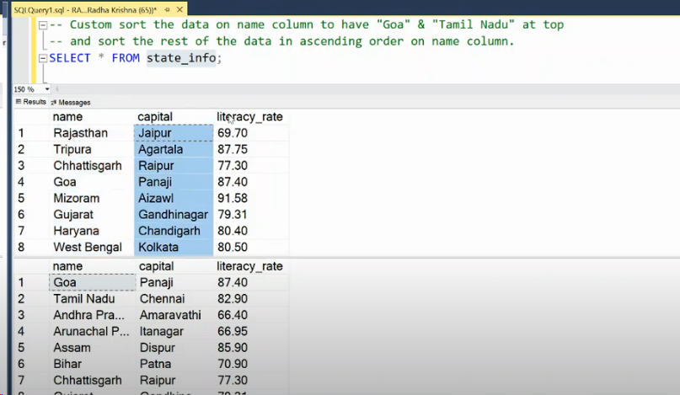

SQL Custom sort | Sorting the records based on state_name column

with cte1 as (

select * ,

case when [name] = 'Goa' then 1

when [name] = 'Tamil Nadu' then 2

else 3 end as [priority]

from state_info

)

select [name],capital,literacy_rate

from cte1

order by [priority],[name]

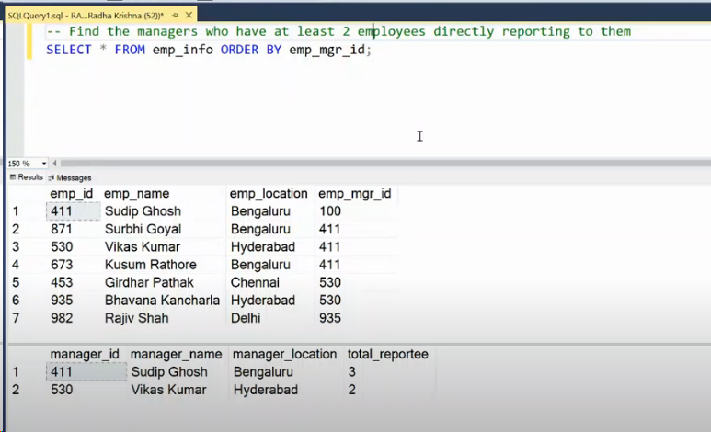

Finding managers having at least 2 employees directly reporting to them

select m.emp_mgr_id as manager_id,m.emp_name as manager_name,m.emp_location as manager_location,count(e.emp_id) as total_repotees from emp_info as e

join emp_info as m

on e.emp_mgr_id = m.emp_id

group by m.emp_mgr_id,m.emp_name,m.emp_location

having count(e.emp_id) >= 2

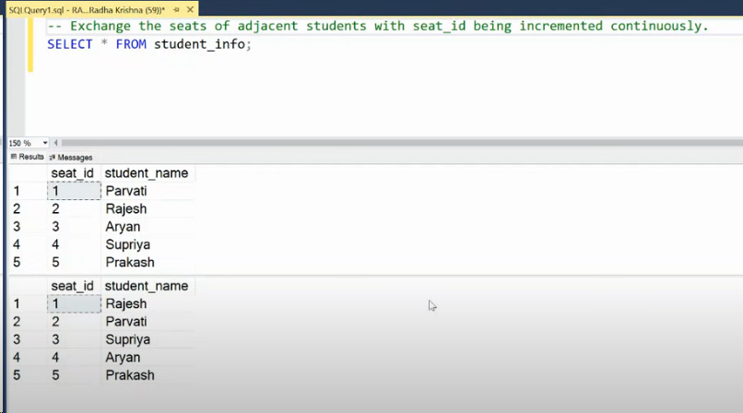

Exchanging seats of adjacent students

with cte1 as (

select *, lead(student_name,1,student_name) over(order by seat_id) as ld,

lag(student_name,1,student_name) over(order by seat_id) as lg,

ROW_NUMBER() over(order by seat_id) as rn

from student_info),odd_seats as (

select seat_id,ld as student_name_n from cte1

where rn%2<>0),even_seats as (

Select seat_id,lg as student_name_n from cte1

where rn%2=0)

select seat_id,student_name_n from odd_seats

union all

select seat_id,student_name_n from even_seats

order by seat_id

Getting first day, last day of the month along with formatted date

DECLARE @input_date date;

set @input_date = '2023-12-05'

select @input_date as ID

select @input_date as input_date ,dateadd(day,1,EOMONTH(@input_date,-1)) as firts_date,EOMONTH(@input_date) as Last_date,format(@input_date,'dd/MM/yyyy') as formated_date

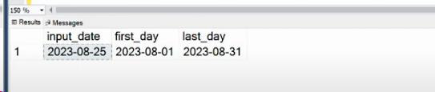

Finding the percentage of immediate orders

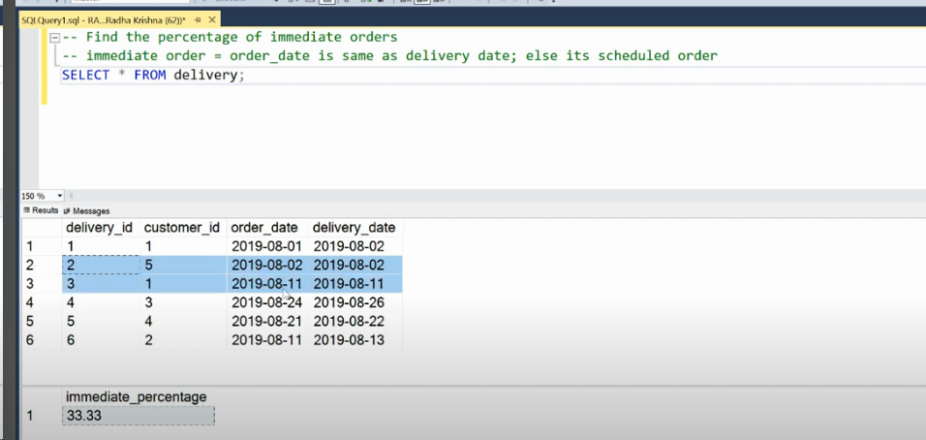

WITH cte1 AS (

SELECT *,

CASE WHEN DATEDIFF(day, order_date, delivery_date) >= 1 THEN 'Schedule_Delivery'

ELSE 'Immediate_Delivery' END AS days_diff

FROM delivery

)

SELECT

round((CAST((SELECT COUNT(days_diff) FROM cte1 WHERE days_diff = 'Immediate_Delivery') AS FLOAT) /

CAST((SELECT COUNT(*) FROM cte1) AS FLOAT))*100,2) AS immediate_percentage;

Finding total item quantity month wise using PIVOT operator

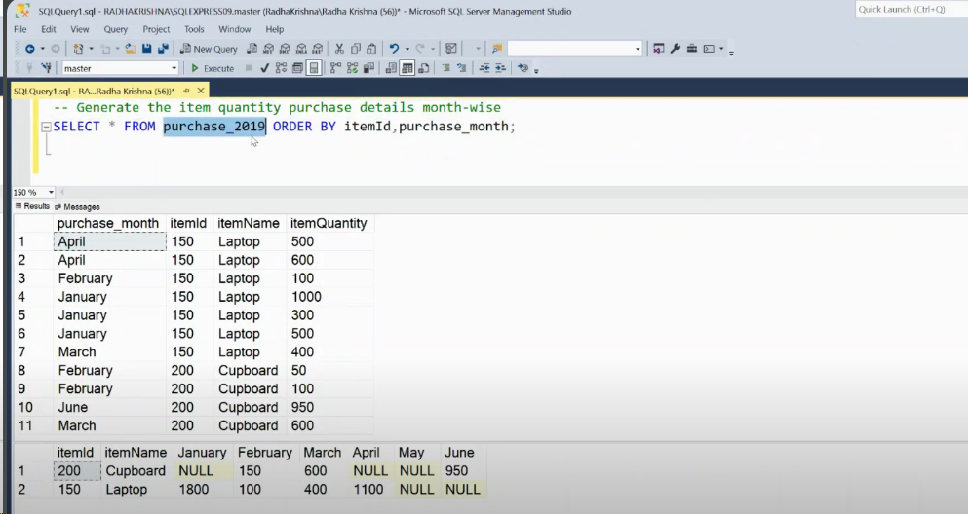

WITH cte1 AS (

SELECT itemId, itemName, purchase_month, SUM(itemQuantity) AS total_quantity

FROM purchase_2019

GROUP BY itemId, itemName, purchase_month

)

SELECT itemId, itemName,

[January], [February], [March], [April]

FROM cte1

PIVOT (

SUM(total_quantity)

FOR purchase_month IN ([January], [February], [March], [April])

) AS PivotTable;

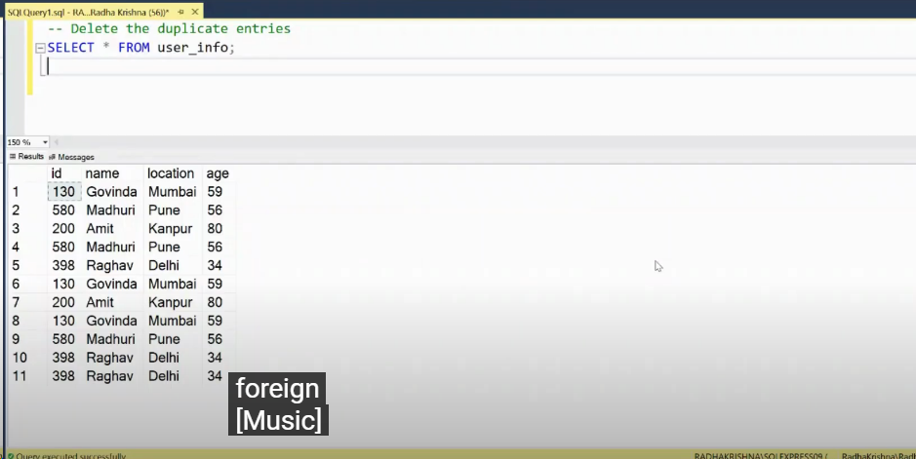

Deleting the duplicate entries

with cte as (

select * , ROW_NUMBER() over(partition by id order by id) as rn

from user_info)

delete from cte

where rn > 1

select * from user_info

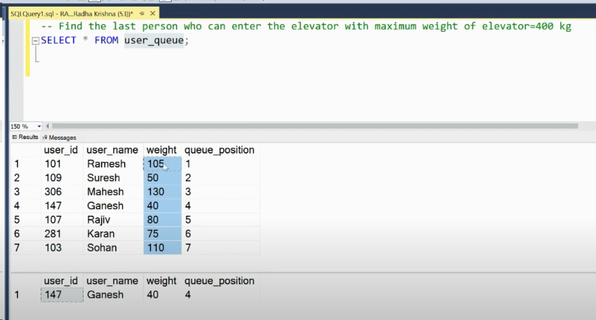

Finding the last person who can enter the elevator using SQL

with cte1 as (

select * , sum(weight) over(order by queue_position) as running_weight from user_queue

) , cte2 as (

select * from cte1

where running_weight <= 400

)

select top 1 user_id,user_name,weight,queue_position from cte2

order by queue_position desc

Checking if challan is applicable

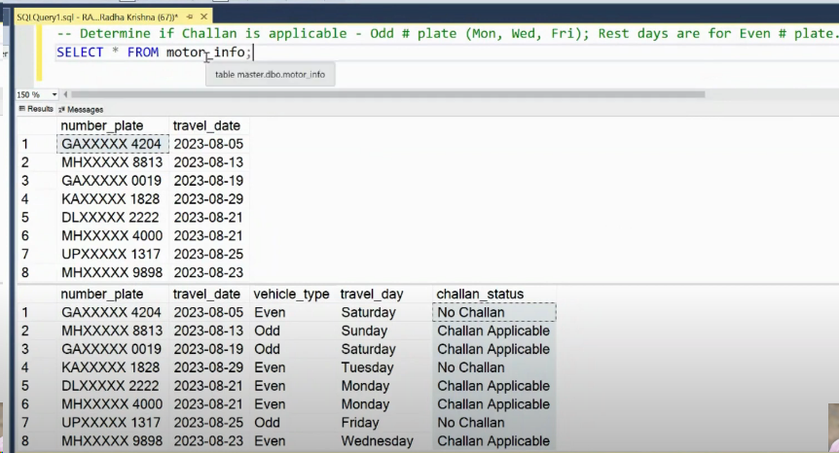

with cte1 as (

select *, DATENAME(weekday,travel_date) as day_name,

case when

cast(right(number_plate,1) as int) % 2 = 0 then 'Even'

else 'odd'

end AS type_of_plate from motor_info)

select * ,

case when type_of_plate = 'Even' and day_name in ('Tuesday','Saturday','Thursday')

then 'No Challan'

when type_of_plate = 'odd' and day_name in ('Monday','Wednesday','Friday')

then 'No Challan'

else 'Challan Applicable' end as challan_staus

from cte1

Fetching the YTD entries for given input date | SQL Problem Solving

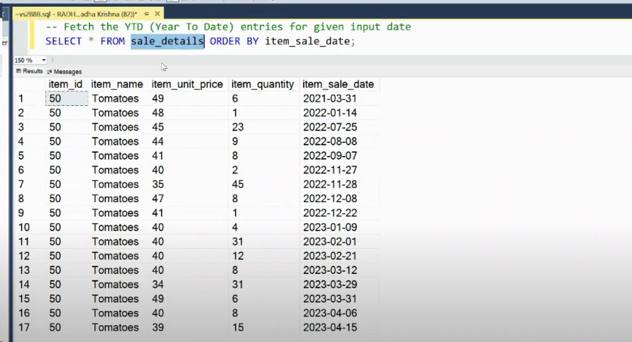

declare @input_date date;

set @input_date = '2023-04-13';

declare @input_year INTEGER;

set @input_year = 2023;

with cte1 as (

select item_id,item_name , item_sale_date,sum(item_unit_price * item_quantity ) as total_price

from sale_details

group by item_id,item_name , item_sale_date

)

select sum(total_price) as total_price from cte1

where item_sale_date <=@input_date and year(item_sale_date) = @input_year

group by item_id,item_name

Getting the file path, name and extension | LEFT | RIGHT | SQL Problem Solving

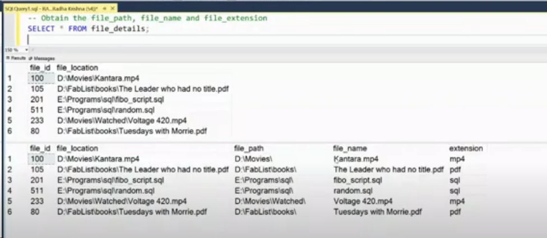

select * ,

left(file_location,len(file_location) - CHARINDEX('\',reverse(file_location))) as [file_Path],

Right(file_location,CHARINDEX('\',reverse(file_location))-1) as [file_name],

RIGHT(file_location,CHARINDEX('.',reverse(file_location))) as file_extenstion

from file_details;

You need to find the cities where not even a single order was returned. In this case the output will be Mysore.

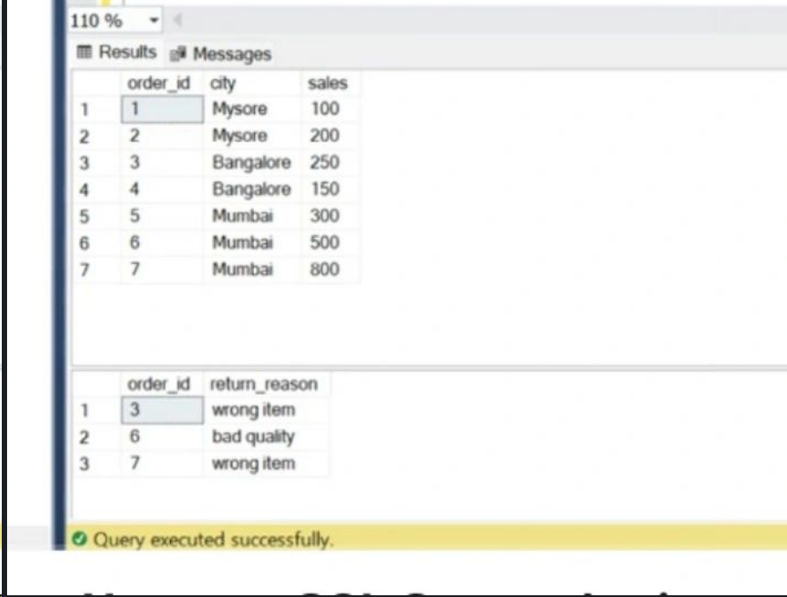

select city from namaste_orders

except

select (o.city) from namaste_orders as o

join namaste_returns as r

on o.order_id = r.order_id

Best SQL Self Join Problem | Finding the best buy and sell date of stocks to get maximum profit

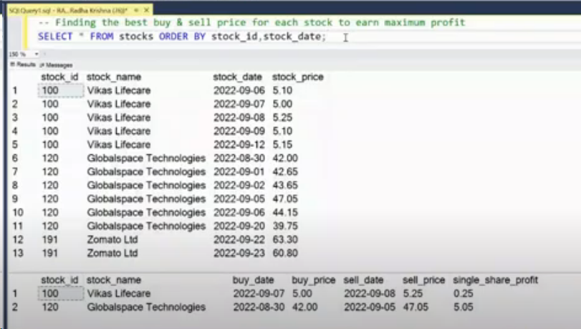

with cte1 as (

select a.stock_id,a.stock_name,a.stock_date as buy_date , a.stock_price as buy_price,

b.stock_date as sell_date , b.stock_price as sell_price,

(b.stock_price-a.stock_price)as profit_per_share

from stocks as a

join stocks as b

on a.stock_id = b.stock_id and a.stock_date < b.stock_date), cte2 as (

select *,DENSE_RANK() over(partition by stock_id order by profit_per_share desc) as rn from cte1)

select stock_id,stock_name,buy_date,buy_price,sell_date,sell_price,profit_per_share from cte2

where rn = 1

Multi Join SQL Problem | Employee & Manager with same number of reportee

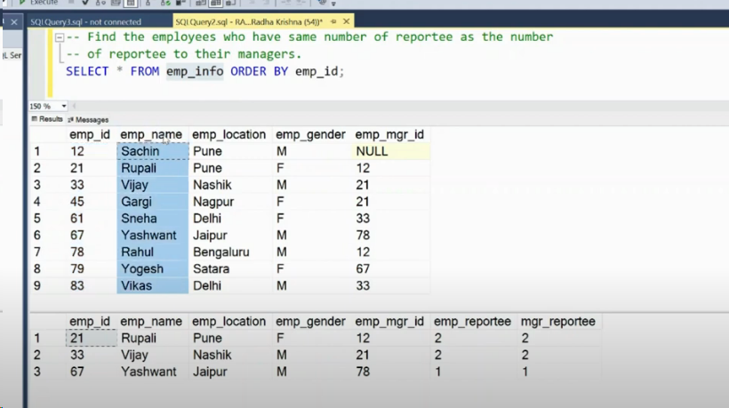

with emp_repo as (

select emp_mgr_id as id , count(*) as repotees

from emp_info

group by emp_mgr_id) , cte2 as (

select e.*,e1.repotees as employee_repotees, e2.repotees as mgr_repotees

from emp_info as e

left join emp_repo as e1

on e.emp_id = e1.id

left join emp_repo as e2

on e.emp_mgr_id = e2.id)

select * from cte2

where employee_repotees = mgr_repotees

Find the expenditure amount in the group

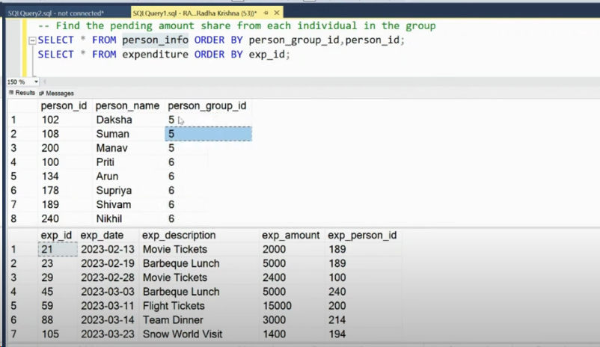

Output :-

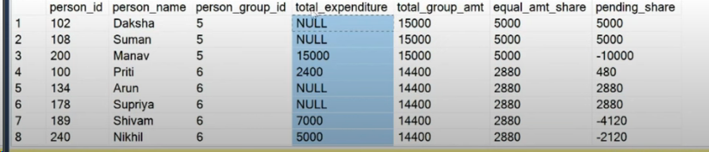

with cte as (

select p.person_id,p.person_name,p.person_group_id,e.exp_amount as total_expenditure,

sum(e.exp_amount) over(partition by p.person_group_id) as total_group_amount,

(sum(e.exp_amount) over(partition by p.person_group_id)/count(*) over(partition by p.person_group_id)) as equal_amt_share

from person_info as p

left join expenditure as e

on p.person_id = e.exp_person_id)

select *,(equal_amt_share - isnull(total_expenditure,0)) as pending_share

from cte

order by person_group_id,pending_share

SQL Self Join Problem to find manager name

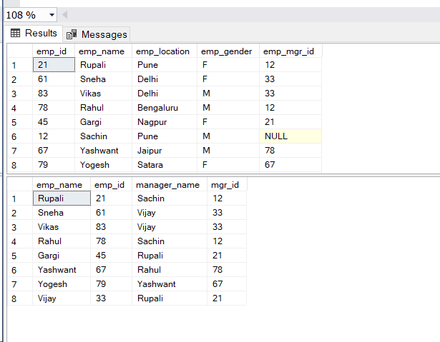

select e.emp_name,e.emp_id,m.emp_name as manager_name , m.emp_id as mgr_id

from emp_info as e

join emp_info as m

on e.emp_mgr_id = m.emp_id

SQL Duplicate Delete Interview Question

with cte_del as (

select *,ROW_NUMBER() over(partition by name,location,age order by name,location,age) as rn

from user_details_dup)

delete from cte_del

where rn >1

Find the total call duration

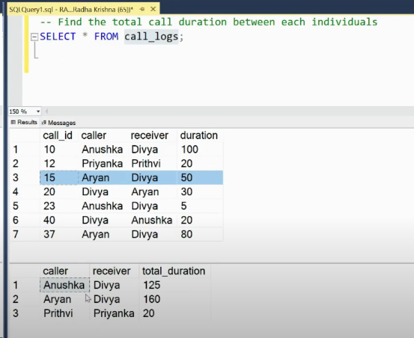

with cte1 as (

SELECT

CASE

WHEN caller < receiver THEN caller

ELSE receiver

END AS participant_1,

CASE

WHEN caller < receiver THEN receiver

ELSE caller

END AS participant_2,

duration AS total_call_duration

FROM

call_logs)

select participant_1,participant_2,sum(total_call_duration) as total_call_duration from cte1

GROUP BY

participant_1,participant_2

SQL Self Join | Frequent Interview Question | Employees with salary greater than their manager

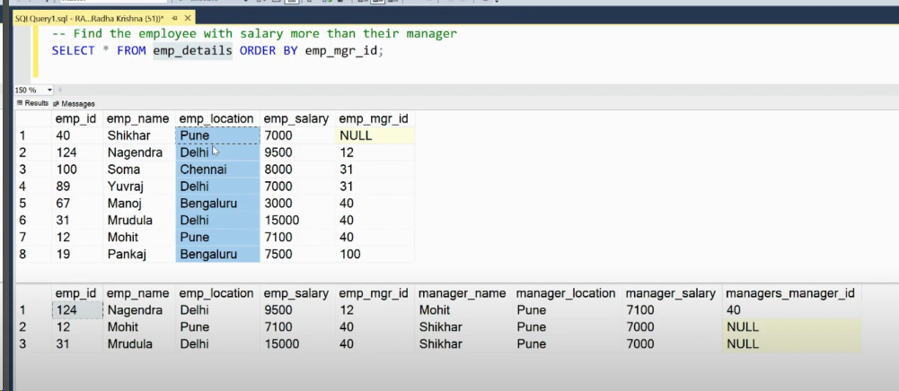

select e.emp_id,e.emp_name,e.emp_location,e.emp_salary,e.emp_mgr_id,

m.emp_name as manager_name, m.emp_location as manager_location,

m.emp_salary as manager_salary,m.emp_mgr_id as managers_managers_id

from emp_details as e

join emp_details as m

on e.emp_mgr_id = m.emp_id and e.emp_salary >= m.emp_salary

SQL CASE Usage in Different way | Finding number of employees hired in a quarter

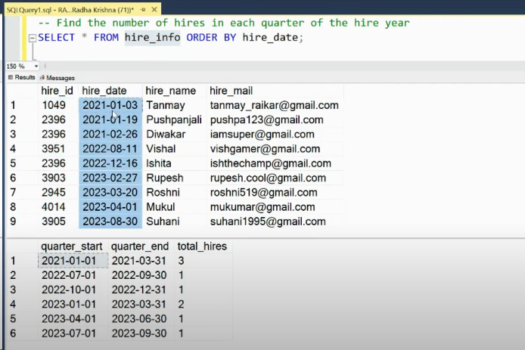

with cte1 as (

select * , datepart(quarter,hire_date) as QTR,

case datepart(quarter,hire_date)

when 1 then FORMAT(hire_date,'yyyy-01-01')

when 2 then format(hire_date,'yyyy-04-01')

when 3 then FORMAT(hire_date,'yyyy-07-01')

when 4 then format(hire_date,'yyyy-10-01')

end as [start_date],

case datepart(quarter,hire_date)

when 1 then FORMAT(hire_date,'yyyy-03-31')

when 2 then format(hire_date,'yyyy-06-31')

when 3 then FORMAT(hire_date,'yyyy-09-31')

when 4 then format(hire_date,'yyyy-12-31')

end as End_Date

from hire_info)

select [start_date],end_date,count(*) as total_hire

from cte1

group by start_date,End_Date

order by start_date,End_Date

SQL Self Join | Finding unique matches between opponentss

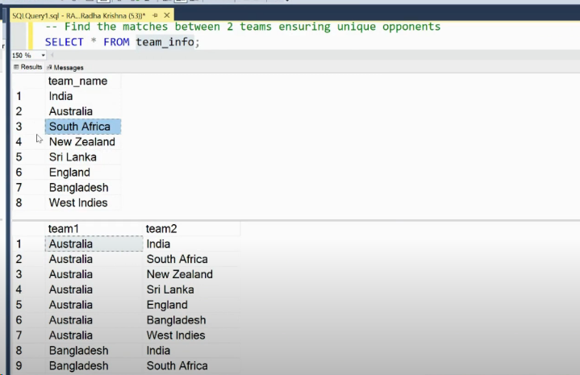

select a.team_name as team_1 , b.team_name as team_2

from team_info as b , team_info as a

where a.team_name <> b.team_name;

SQL Pattern Generation | Generating the Right half Pyramid pattern | Recursive CTE

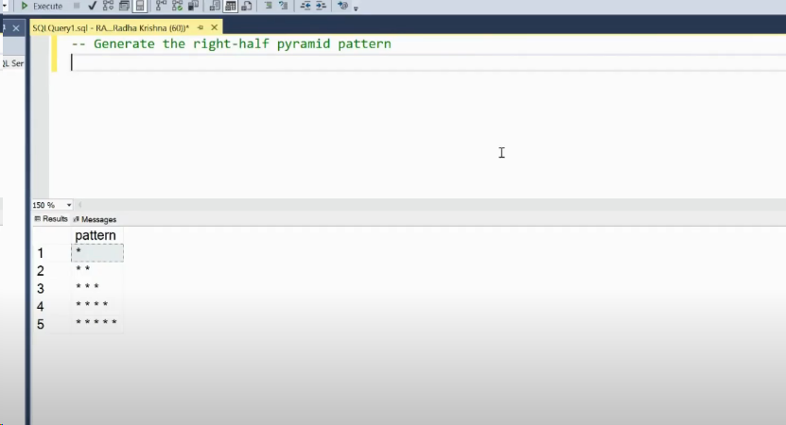

with cte as (

select 1 as num

union all

select num+1 from cte

where num <5

)

select replicate('*',num) from cte

SQL INNER or LEFT Join? | Finding list of reportees to manager

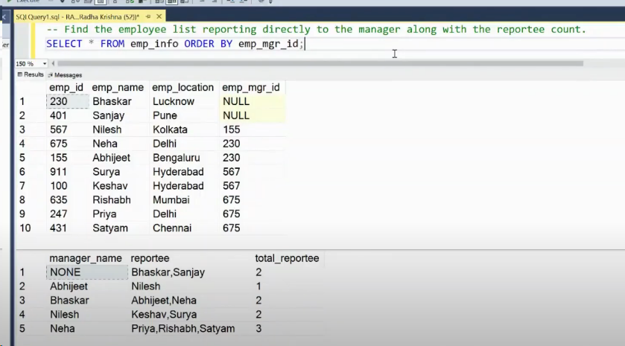

with cte as (

select e.emp_name as manager_name ,m.emp_name as employee_name

from emp_info_join as m

left join emp_info_join as e

on m.emp_mgr_id = e.emp_id)

select

case when manager_name is null then 'NONE' else manager_name end as manager_name,

STRING_AGG(employee_name,',') as repotte,

count(employee_name) as total_reportees

from cte

group by manager_name

SQL Interview Salary Problem | Employees with salary greater than department average salary

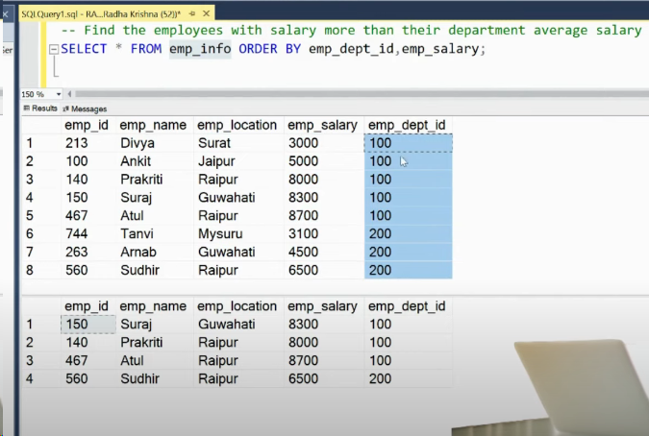

with cte1 as (

select emp_dept_id,avg(emp_salary) as avg_salry from emp_info_avg

group by emp_dept_id),cte2 as (

select * from emp_info_avg)

select a.* from cte2 as a

join cte1 as b

on a.emp_dept_id = b.emp_dept_id and a.emp_salary > b.avg_salry

SQL Customer Frequent Interview Question | 3 Approaches | Customers who have not placed any order

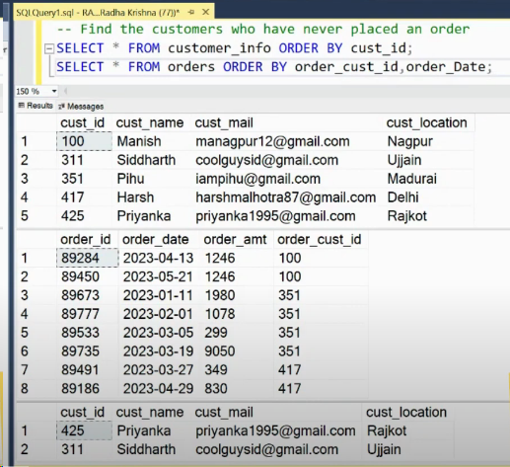

-- way 1

select * from customer_info

where cust_id not in (select distinct order_cust_id from orders_info)

-- way 2

select a.* from customer_info as a

left join orders_info as b

on a.cust_id = b.order_cust_id

where b.order_cust_id is null;

-- way 3

select * from customer_info as a

where not exists (select distinct order_cust_id from orders_info as b

where a.cust_id = b.order_cust_id)

Customer Orders SQL Problem | Find 3 consecutive orders within 7 days

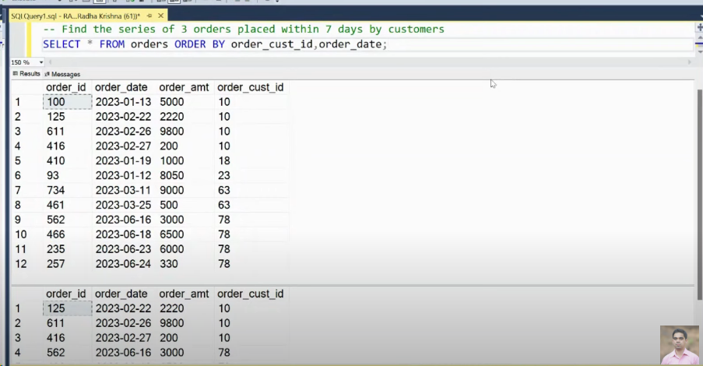

with order_cte as (

select * , lead(order_date) over(partition by order_cust_id order by order_date asc) as order_2,

lead(order_date,2) over(partition by order_cust_id order by order_date asc) as order_3

from orders_cont), customer_cte as

(select order_cust_id,order_date as order_1,order_2,order_3

from order_cte

where DATEDIFF(DAY,order_date,order_2) <= 7 and DATEDIFF(DAY,order_date,order_3)<=7)

select o.order_id,o.order_date,o.order_amt,o.order_cust_id from order_cte as o

join customer_cte as c

on o.order_cust_id = c.order_cust_id and o.order_date between c.order_1 and c.order_3

SQL Third highest score with Twist | SQL Problem Solving

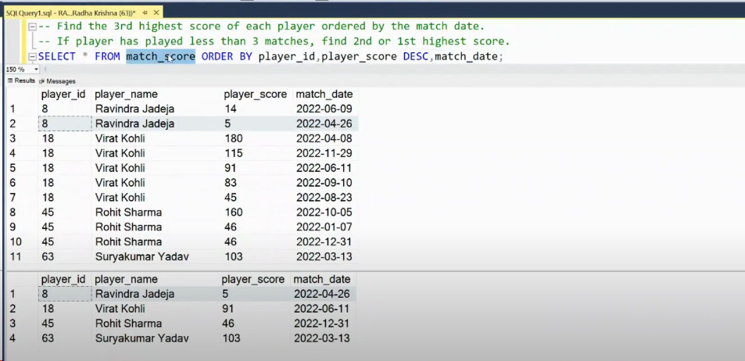

with cte1 as (

select * , dense_rank() over(partition by player_id order by player_score desc,match_date asc) as dr,

count(*) over(partition by player_id) as cnt_matches

from match_score_high)

select player_id,player_name,player_score,match_date

from cte1

where dr=3 or (cnt_matches <3 and dr = cnt_matches);

SQL Multi Join Interesting Problem | Finding the employees moved to next level

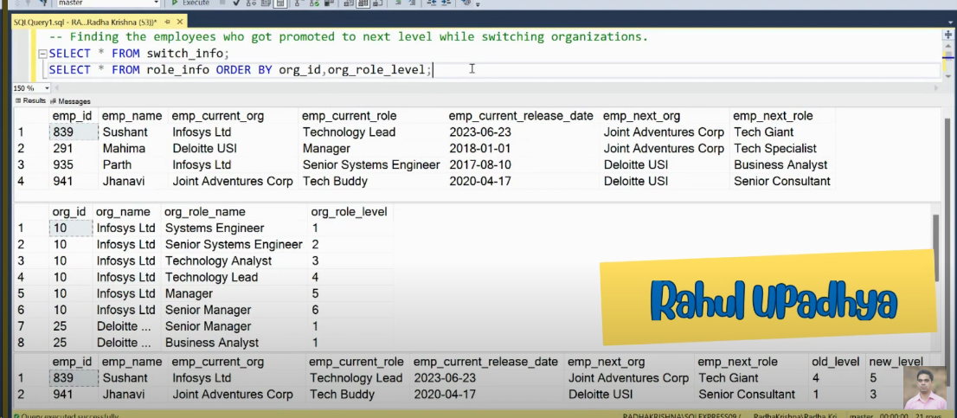

with current_role as (

select a.emp_id,b.org_role_level as old_level

from switch_info as a

join role_info as b

on a.emp_current_org = b.org_name and a.emp_current_role = b.org_role_name), new_role as (

select a.emp_id,b.org_role_level as new_level

from switch_info as a

join role_info as b

on a.emp_next_org = b.org_name and a.emp_next_role = b.org_role_name)

select e.*,c.old_level,n.new_level

from switch_info as e

join current_role as c

on e.emp_id = c.emp_id

join new_role as n on e.emp_id = n.emp_id

where c.old_level < n.new_level